**CSA1313- THEORY OF COMPUTATION**

S.Harshavardhan

192211975

1. Design PDA using simulator to accept the input string anbn

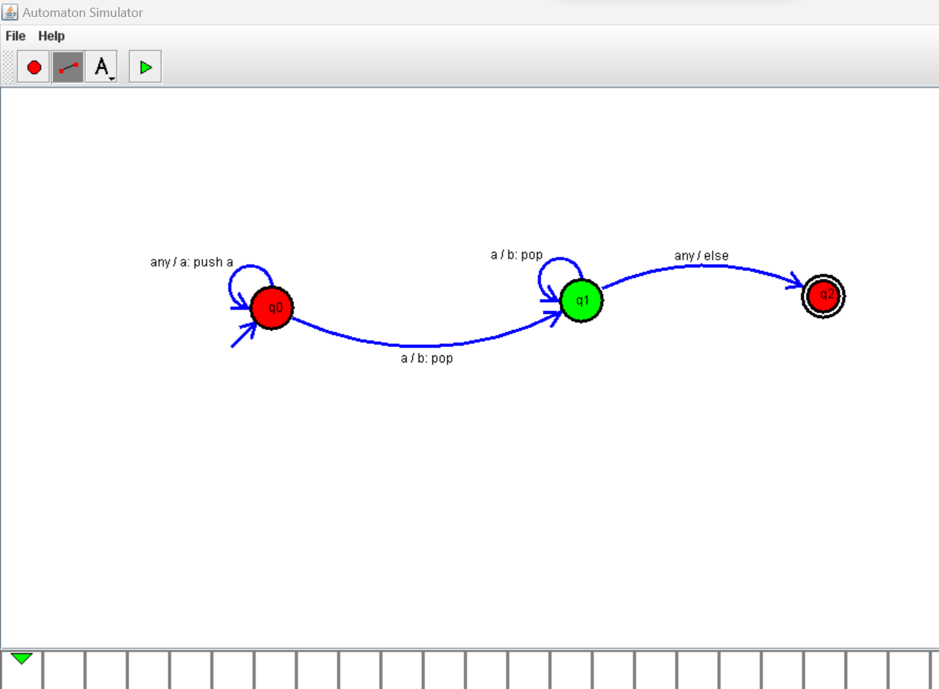

1. Design PDA using simulator to accept the input string anb2n

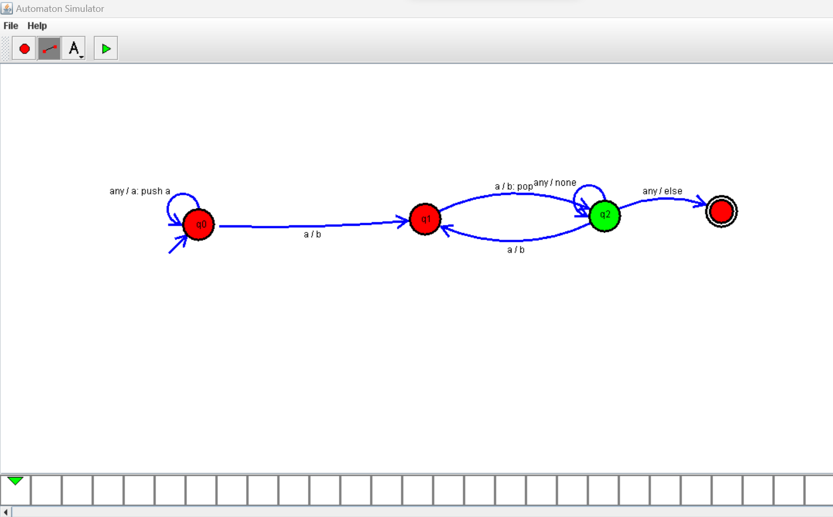

1. Design PDA using simulator to accept the input string aabb

